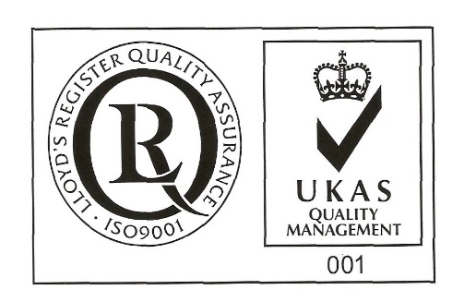
ŞANTIERUL NAVAL ORŞOVA S.A.
Nr. RC J25/150/1991 CIF: RO 1614734
Capital social: - subscris 28.557.297,5 lei
- varsat 28.557.297,5 lei
Str. Tufări, nr. 4, Orşova, 225200, Mehedinţi

Tel.: 0252/362.399; 0252/361.885; Fax: 0252/360.648
E-mail: mircea.sperdea@snorsova.ro; marketing@snorsova.ro
Codul LEI (Legal Entity Identifier): 254900UXAJ8TPIKLXG79
Cod IBAN: RO96RNCB0181022634120001- B.C.R. Orşova

Cod IBAN: RO59BRDE260SV03176142600- B.R.D. Orşova

SPECIAL EMPOWERMENT

Subscribed ______________________, with headquarter in ___________ str. _____ nr. ____, county ___________, unic registration code ____________, registered at Comemerce Registry Office around Court __________ under no. J/_______/_____, legally represented by ______________________, having function _______________, owner of a number ________of shares, , representing __% from joint stock of its, which gives me a _____ number of votes in Ordinary General Meeting of Shareholders SANTIERUL NAVAL ORSOVA SA to be held in 15.04.2022, 10 o’clock, at society’s headquarter, concluded for the first convocation, or in 16.04.2022 at the same hour and address, concluded as being second convocation, in case that the first one can not be held, I empower Mr./ Mrs.________________________, identified by ID CARD series ______ no._________________, PNC_________________________, to represent me in this General Meeting and to exert my vote right afferent to my holdings registered at the reference date in Shareholders Registry, as follows:
Points on the agenda to be voted on General Meeting of Shareholders | PRO | AGAINST | ABSTENTION
1. Election of the meeting secretariat consisting of three members, respectively Mrs. Maria Carstoiu, Mrs. Carmen Inca and Mr. Horia Ciorecan, shareholders with the identification data available at the company's headquarters, in charge of verifying the presence of shareholders, fulfilling the formalities required by law and the constitutive act for holding the general assembly, counting the votes expressed during the meeting of the general assembly and drawing up the minutes of the meeting;
2. Presentation of the report on the results of the revaluation of tangible assets from the construction and ship groups. Approval of the registration of the revaluation differences amounting to 3,301,954.11 lei in the accounting records on 31.12.2021.
3. Presentation, debate and approval of the annual financial statements for the financial year 2021, prepared in accordance with the International Financial Reporting Standards, on the basis of the Management Report of the Board of Directors and the Statutory Auditor's Report.
4. Presentation and submission of the advisory vote of the Remuneration Report for the financial year 2021;
5. Approval that from the result carried forward, representing the surplus realized from revaluation reserves, the amount of 177,845.77 lei to be distributed on the following destinations:
• 153,869.94 lei to cover the net accounting loss;
• 23,975.83 lei to cover the loss from the correction of accounting errors from the previous period;
6. Discharge of administrators for the financial year 2021.
7. Approval of the maintenance at the current level of remuneration due to the directors, valid from the date of this Ordinary General Meeting of Shareholders until the date of the next Ordinary General Meeting of Shareholders.
8. Approval of performance indicators and objectives for the financial year 2022, annex to the administration and mandate contract.
9. Approval of the draft Budget of Revenues and Expenditures and of the investment program for 2022, according to the proposal of the administrators.
11. Approval of the performance in the financial year 2022 of the accounting registration at “income” of the dividends not collected for more than 3 years from the due date, for which the right to dividend is extinguished by prescription, respectively the dividends related to the financial year 2017 unpaid on 31.12.2021, in the amount of 49,159.38 lei;
12. Approval of the date of May 20, 2022 as the registration date for identifying the shareholders affected by the decision of the ordinary general meeting of shareholders and the date of May 19, 2022 as ex date, according to art. 187 (point 11) of the FSA Regulation no. 5/2018 on issuers of financial instruments and market operations with subsequent amendments and completions.
13. Empowerment of Mr. Mircea Ion Sperdea, General Manager of the company, to sign the decision of the Ordinary General Meeting of Shareholders (OGMS) and any other acts necessary to implement the OGMS decision and to perform the formalities of publicity and registration.
The vote will expressed by marking with “X” in only one box coresponding to vote intention, respectively “ PRO”, “ AGAINST” or “ABSTENTION”, for each resolution in part.

Date _________________

Stamp and signature (legal representative) _______________________ ________
(in the case of the use of the empowerment, in case of the registration by registry or by post or courier)

or:
EXTENDED ELECTRONIC SIGNATURE (when the empowerment is transmitted by electronic means)

NAME AND FIRST NAME / NAME OF THE SHAREHOLDER ________________________________________
(to be filled in in capital letters)

