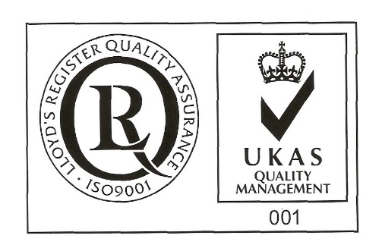
ŞANTIERUL NAVAL ORŞOVA S.A.
Nr. RC J25/150/1991 CIF: RO 1614734
Capital social: - subscris 28.557.297,5 lei
- varsat 28.557.297,5 lei
Str. Tufări, nr. 4, Orşova, 225200, Mehedinţi

Tel.: 0252/362.399; 0252/361.885; Fax: 0252/360.648
E-mail: mircea.sperdea@snorsova.ro; marketing@snorsova.ro
Codul LEI (Legal Entity Identifier): 254900UXAJ8TPIKLXG79
Cod IBAN: RO96RNCB0181022634120001- B.C.R. Orşova

Cod IBAN: RO59BRDE260SV03176142600- B.R.D. Orşova

VOTE BULLETIN¹
BY CORRESPONDENCE OF LEGAL PERSONS
Dedicated to item 10 on the OGMS agenda
Subscribed ______________________, with headquarter in ___________ str. _____ nr. ____, county ___________, unic registration code ____________, registered at Comemerce Registry Office around Court __________ under no. J/_______/_____, legally represented by ______________________, having function _______________, owner of a number ________of shares, , representing __% from joint stock of its, which gives me a _____ number of votes in Ordinary General Meeting of Shareholders SANTIERUL NAVAL ORSOVA SA to be held in 15.04.2022, 10 o’clock, at society’s headquarter, concluded for the first convocation, or in 16.04.2022 at the same hour and address, concluded as being second convocation, in case that the first one can not be held, I exert my vote right afferent to my holdings registered at reference date in Shareholders Registry, as follows:
Points on the agenda to be voted on General Meeting of Shareholders | PRO | AGAINST |  | ABSTENTION
10. Election of the company's external auditor and fixing the duration of the external financial audit contract, taking into account the expiration of the auditor's contract in office. Mandating the Board of Directors to negotiate and conclude the external financial audit contract.
ABA AUDIT SRL

¹This form, completed by the shareholder and accompanied by a copy of the identity document of the legal representative of the legal person shareholder, as well as the official document attesting the quality of legal representative ((The capacity of legal representative is proved by a certificate issued by the Comemerce Registry Office, presented in original or copy in accordance with the original, or any other document, in original or in copy in accordance with the original, issued by a competent authority of the state in which the shareholder is legally registered, which certifies the quality of legal representative. The document certifying the quality of legal representative of the shareholder legal entity is valid if it was issued no later than 3 months before the publication of this call), must reach the company by April 13, 2022, in a separate, closed envelope, indicating on the envelope, clearly "Confidential - Secret voting instructions for the Ordinary General Meeting of Shareholders dated 15 / 16.04.2022” and which will be introduced, in turn, in the envelope containing the voting paper by correspondence dedicated to the other items on the OGMS agenda and the related documents. The powers of attorney can also be sent by separate e-mail until the deadline mentioned above, by a document signed with an extended electronic signature, according to Law no. 455/2001 regarding the electronic signature - by e-mail to the address: marilena.visescu@snorsova.ro, mentioning in the subject of the e-mail, clearly „Confidential - Secret voting instructions for the Ordinary General Meeting of Shareholders dated 15 / 16.04.2022".
*The vote will expressed by marking with “X” in only one box coresponding to vote intention, respectively
“ PRO”, “AGAINST” or “ABSTENTION”, for each resolution in part.
The shareholder assumes full responsibility for the correct completion and safe transmission of this voting paper.
Date _________________
Shareholder's signature: __________________________ (in the case of the use of the empowerment, in case of the registration by registry or by post or courier)
or:
EXTENDED ELECTRONIC SIGNATURE (when the empowerment is transmitted by electronic means)

NAME AND FIRST NAME / SURNAME OF THE SHAREHOLDER _____________________________________ (to be filled in in capital letters)

