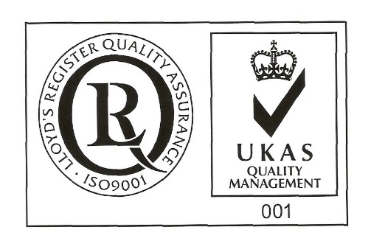
ŞANTIERUL NAVAL ORŞOVA S.A.
Nr. RC J25/150/1991 CIF: RO 1614734
Capital social: - subscris 28.557.297,5 lei
- varsat 28.557.297,5 lei
Str. Tufări, nr. 4, Orşova, 225200, Mehedinţi

Tel.: 0252/362.399; 0252/361.885; Fax: 0252/360.648
E-mail: mircea.sperdea@snorsova.ro; marketing@snorsova.ro
Codul LEI (Legal Entity Identifier): 254900UXAJ8TPIKLXG79
Cod IBAN: RO96RNCB0181022634120001- B.C.R. Orşova

Cod IBAN: RO59BRDE260SV03176142600- B.R.D. Orşova

VOTE BULLETIN
BY CORRESPONDENCE OF LEGAL PERSONS
Subscribed ______________________, with headquarter in ___________ str. _____ nr. ____, county ___________, unic registration code ____________, registered at Comemerce Registry Office around Court __________ under no. J/_______/_____, legally represented by ______________________, having function _______________, owner of a number ________of shares, , representing __% from joint stock of its, which gives me a _____ number of votes in Ordinary General Meeting of Shareholders SANTIERUL NAVAL ORSOVA SA to be held in 24.11.2022, 11 o’clock, at society’s headquarter, concluded for the first convocation, or in 25.11.2022 at the same hour and address, concluded as being second convocation, in case that the first one can not be held, I exert my vote right afferent to my holdings registered at reference date in Shareholders Registry, as follows:

Points on the agenda to be voted on General Meeting of Shareholders | PRO | AGAINST | ABSTENTION
1.Election of the meeting secretariat consisting of three members, respectively Mrs. Maria Carstoiu, Mrs. Carmen Inca and Mr. Horia Ciorecan, shareholders with the identification data available at the company's headquarters, in charge of verifying the presence of shareholders, fulfilling the formalities required by law and the constitutive act for holding the general assembly, counting the votes expressed during the meeting of the general assembly and drawing up the minutes of the meeting.
2.Approval of the distribution of the amount of 6,054,147.07 lei, respectively a gross dividend of 0.53 lei/share, from the profit reconstituted by transferring the amount from the balance on 31.12.2021 of the "Other reserves" account to the dividend account, as a result of the return on the distribution approved by AGOA in previous years of the net profit.
3.Approval of the date of December 13, 2022 as the registration date for identifying the shareholders affected by the decision of the ordinary general meeting of shareholders and the date of December 12, 2022 as ex date, according to art. 187 (point 11) of the FSA Regulation no. 5/2018 on issuers of financial instruments and market operations with subsequent amendments and completions.
4.Approval of December 22, 2022 as the dividend payment date established in point 2 above, in accordance with the provisions of art. 187, point 11 of ASF Regulation no. 5/2018 regarding issuers of financial instruments and market operations, with subsequent amendments and additions. The costs related to the payment of dividends will be borne by the beneficiary shareholders, from the value of the net dividend.
5.Empowerment of Mr. Mircea Ion Sperdea, General Manager of the company, to sign the decision of the Ordinary General Meeting of Shareholders (OGMS) and any other acts necessary to implement the OGMS decision and to perform the formalities of publicity and registration.

- the vote will expressed by marking with “X” in only one box coresponding to vote intention, respectively “ PRO”, “ AGAINST” or “ABSTENTION”, for each resolution in part.

Date _________________

Stamp and signature___________

