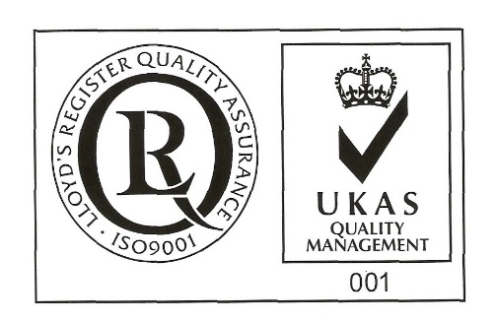
ŞANTIERUL NAVAL ORŞOVA S.A.
Nr. RC J25/150/1991 CIF: RO 1614734
Capital social: - subscris 28.557.297,5 lei
- varsat 28.557.297,5 lei
Str. Tufări, nr. 4, Orşova, 225200, Mehedinţi

Tel.: 0252/362.399; 0252/361.885; Fax: 0252/360.648
E-mail: mircea.sperdea@snorsova.ro; marketing@snorsova.ro
Codul LEI (Legal Entity Identifier): 254900UXAJ8TPIKLXG79
Cod IBAN: RO96RNCB0181022634120001- B.C.R. Orşova

Cod IBAN: RO59BRDE260SV03176142600- B.R.D. Orşova

VOTE BULLETIN
BY CORRESPONDENCE OF PHYSICAL PERSONS

The Undersigned, __________________________________, identified by ID CARD series ______ no._________________, PNC_________________________, owner of _________no of shares, representing __% from joint stock of its, which gives me a _____ number of votes in Ordinary General Meeting of Shareholders SANTIERUL NAVAL ORSOVA SA to be held in 22.04.2024, 10 o’clock, at society’s headquarter, concluded for the first convocation, or in 23.04.2024 at the same hour and address, concluded as being second convocation, in case that the first one can not be held, I exert my vote right afferent to my holdings registered at reference date in Shareholders Registry, as follows:

Points on the agenda to be voted on General Meeting of Shareholders | PRO | AGAINST | ABSTENTION
1.Election of the meeting secretariat consisting of three members, respectively Mrs. Maria Carstoiu, Mrs. Carmen Incă and Mr. Horia Ciorecan, shareholders with identification data available at the company's headquarters, in charge of verifying the presence of shareholders, fulfilling the formalities required by law and the constitutive act for holding the general assembly, counting the votes cast during the general assembly meeting and drawing up the minutes of the meeting;
2.Presentation of the report on the results of the revaluation of tangible assets from the ship group. Approval of recording the differences from the revaluation in the net amount of 269,048.14 lei in the accounting records on 12.31.2023;
3.Presentation, discussion and approval of the annual financial statements, related to the financial year 2023, drawn up in accordance with the International Financial Reporting Standards, based on the Management Report of the Board of Directors and the Report of the statutory financial auditor;
4.The approval that the amount of 1,367,084.18 lei be used to cover the net accounting loss from the carried forward result, representing the surplus made from revaluation reserves;
5.Approval of the distribution of the net profit achieved in 2023. The Board of Directors proposes that the net profit in the amount of 3,453,687.23 lei be distributed to the following destinations:
- 2,848,032.44 lei to cover the net accounting loss
- 605,654.79 lei as own source of financing;
6.Approval of the Revenue and Expenditure Budget and the investment program for the year 2024, according to the administrators' proposal;
7.Presentation and submission for approval of the Remuneration Report for the 2023 financial year;
8.Discharge of administrators for the 2023 financial year;
10.Discharge of administrators who were not reconfirmed by cumulative vote in the new Board of Directors for the activity carried out in the financial year of 2024;
11.Approval of the fixed remuneration due to administrators for the financial year 2024, according to art. 19 (2) of the Constitutive Act, at the level approved by the shareholders for the financial year 2023;
12.Approval of the conclusion of the Administration Contract with the members of the Board of Administration;
13.Approval of performance indicators and objectives for the financial year 2024, annex to the administration and mandate contract;
14.Appointment of Mr. Mircea Ion Sperdea for signing the Administration Contract with the members of the Board of Directors, as a conventional representative on behalf of the company;
15.Approval of making in the financial year 2024 the accounting registration under "revenues" of
dividends not collected for more than 3 years from the due date, for which the right to the dividend is extinguished by prescription, respectively the dividends related to the financial year 2019 existing in the balance as unpaid on 31.12.2023, in the amount of 67,446.42 lei;
16.Approval of the date of July 2, 2024 as the registration date and of the ex-date of July 1, 2024 for the identification of the shareholders affected by the decision of the Ordinary General Meeting of Shareholders;
17. The authorization of Mr. Mircea Ion Sperdea, general manager of the company, to sign the decision of the ordinary general meeting of shareholders (AGMA) and any other documents necessary to implement the AGMA decision and to carry out the formalities of its publication and registration.
18. Approval of the form of the administration contract to be concluded with the members of the Board of Administration.

- the vote will expressed by marking with “X” in only one box coresponding to vote intention, respectively “ PRO”, “ AGAINST” or “ABSTENTION”, for each resolution in part.
Date _________________

Signature______________

