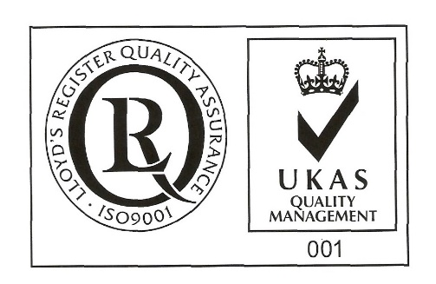

ŞANTIERUL NAVAL ORŞOVA S.A.
Nr. RC J25/150/1991 CIF: RO 1614734
Capital social: - subscris 28.557.297,5 lei
- varsat 28.557.297,5 lei
Str. Tufări, nr. 4, Orşova, 225200, Mehedinţi

Tel.: 0252/362.399; 0252/361.885; Fax: 0252/360.648
E-mail: mircea.sperdea@snorsova.ro; marketing@snorsova.ro
Codul LEI (Legal Entity Identifier): 254900UXAJ8TPIKLXG79
Cod IBAN: RO96RNCB0181022634120001- B.C.R. Orşova

Cod IBAN: RO59BRDE260SV03176142600- B.R.D. Orşova

SPECIAL EMPOWERMENT

The Undersigned, __________________________________, identified by ID CARD serie ______ no._________________, PNC_________________________, owner of _________no of shares, representing __% from joint stock of its, which gives me a _____ number of votes in Extraordinary General Meeting of Shareholders SANTIERUL NAVAL ORSOVA SA to be held in 25.02.2026, 10 o’clock, at society’s headquarter, concluded for the first convocation, or in 26.02.2026 at the same hour and address, concluded as being second convocation, in case that the first one can not be held, I empower Mr./ Mrs.________________________, identified by ID CARD series ______ no._________________, PNC_________________________, to represent me in this General Meeting and to exert my vote right afferent to my holdings registered at the reference date in Shareholders Registry, as follows:

Points on the agenda to be voted on General Meeting of Shareholders | PRO | AGAINST | ABSTENTION
1.Election of the meeting secretariat consisting Mr. Horia Ciorecan, shareholder with the identification data available at the company's headquarters, in charge of verifying the presence of shareholders, fulfilling the formalities required by law and the constitutive act for holding the general assembly, counting the votes expressed during the meeting of the general assembly and drawing up the minutes of the meeting.
2.Approval of the sale of the following movable assets of a maritime transport nature – 4 barge-type vessels: Midia 5 identified with IMO number 8829983, Midia 6 identified with IMO number 8829995, Midia 8 identified with IMO number 8830011 and Midia 21 identified with IMO number 7906758, at the total price of EUR 2,350,000 to which VAT is applied according to the legal provisions in force.Designation of the person authorized to sign the sale contract of the assets mentioned in art.2.
3.Approval of the authorization of the Agigea Branch Manager and/or the General Manager of the company to draw up, negotiate, agree and decide on the conditions for the sale of movable assets within the limits of the EGMS decision, as well as the authorization of the Agigea Branch Manager and/or the General Manager of the company to sign and execute, in the name and on behalf of the Company, the sale-purchase contract for the sale of the movable assets mentioned in point 2, as well as any other prior notifications, documents, acts or documents necessary or useful for the valid conclusion and execution of the sale of the movable assets mentioned in point 2.
4.Approval of the date of March 25, 2026 as the registration date and the ex-date of March 24, 2026 for identifying the shareholders on whom the effects of the decision of the Extraordinary General Meeting of Shareholders are reflected.
5.Empowerment of Mr. Mircea Ion Sperdea, General Manager of the company, to sign the decision of the Extraordinary General Meeting of Shareholders (EGMS) and any other acts necessary to implement the EGMS decision and to perform the formalities of publicity and registration.

The vote will expressed by marking with “X” in only one box coresponding to vote intention, respectively “ PRO”, “ AGAINST” or “ABSTENTION”, for each resolution in part.
Date _________________
Shareholder's signature: __________________________
(in the case of the use of the empowerment, in case of the registration by registry or by post or courier)
or:
EXTENDED ELECTRONIC SIGNATURE (when the empowerment is transmitted by electronic means)
NAME AND FIRST NAME / SURNAME OF THE SHAREHOLDER ________________________________________
(to be filled in in capital letters)

